## Parent Notification Letter

**Important: All Renaissance 360 Assessments should be completed by Aug. 27th**

Dear Families,

As you may already know, our school uses Renaissance 360 Assessments to help teachers understand what students know and what they are ready to learn next. Typically, these assessments are given throughout the school year to monitor student progress and are administered in the school setting. Part of our normal testing plan includes a fall, beginning of the year assessment. After careful consideration, knowing the value of this data to make informed instructional decisions for your child, we will be administering the assessment remotely.

In order to support your child on this assessment, you will need to:

* Use the **Parent/Guardian Ren 360 Checklist** (see next page)
* Have your student follow the **Student** **Login Instructions** in the box to the right. **1Link can be found on the Fort Bend ISD home page.**
* Complete the required assessments listed in the box below between **August 20th and August 27th.**
* If at any time the program prompts your child to enter a monitor password to continue the assessment, please enter **FBISD** in all capitals
* Navigating Renaissance 360 Parent Video: <https://youtu.be/17ZGrKfKcCk>

**Ren 360**

Student Login Instructions:

* Log in through 1Link
* Go to Schoology
* Click the 2x2 grid tile located to the right of the magnifying glass.

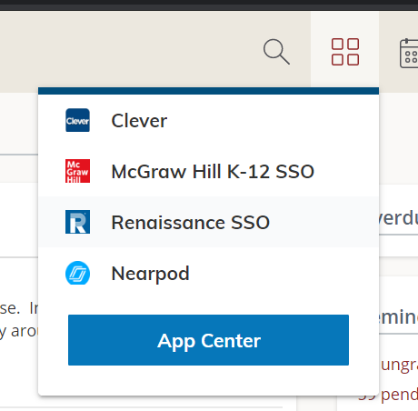

* Click Renaissance SSO
* Select the assigned assessment: STAR Early Literacy, STAR Reading, STAR Math

|  |  |  |
| --- | --- | --- |
| **Grade Level** | **Assessments Taken** | **Suggested Testing Dates** |
| **Kindergarten** | **Early Literacy** | **August 20, 2020** |
| **1st Grade** | **Early Literacy,**  **Math &**  **Reading** | **August 20, 2020**  **August 21, 2020**  **August 24, 2020** |
| **2nd-5th Grade** | **Math &**  **Reading** | **August 20, 2020**  **August 21, 2020** |

Thank you for partnering with us through this assessment process. For more information about Renaissance Assessments, visit the Renaissance [parent webpage.](https://www.renaissance.com/services/parent-resources/assessments-testing/)

**Ren 360 Parent/Guardian Checklist**

To ensure your school has timely and accurate data to better support instructional decisions for your child, please follow this checklist for Renaissance 360 At-Home Testing.

|  |  |
| --- | --- |
| **Before Testing** | |
|  | Ensure student has had a good breakfast. |
|  | Select a quiet place in the home for students to complete the assessment. |
|  | Students should take the assessments on the suggested testing days. Teachers will allot time during asynchronous learning for students to take the tests. The asynchronous activities will be reduced on the scheduled testing dates |
|  | Check technology equipment to determine all is in working order and enable “full screen” mode on browser to ensure students will see the full items without scrolling. |
|  | If possible, attend the Renaissance training for parents on August 18th (see schedule below) |
|  | Log in to Schoology through 1Link (icon can be found on the FortBendISD.com home page) to access the Renaissance platform.  (Follow Student Login Instructions) |
|  | Ensure that student can log in and access the Renaissance 360 assessments. |
|  | Ensure that students have paper and pencil to use for note taking and calculations during the assessment. |
|  | Set the tone before starting the assessment. Explain to your child that they will be taking an assessment and that you will not be able to help them with answers. If they have trouble with technology, you may help them. |
| **During Testing** | |
|  | Monitor the student during testing.   * Stay nearby where your child is testing to ensure they remain focused but avoid hovering and distracting. * Students should ***complete each assessment in one sitting***. They should not go to other pages on the web or use any other sources to complete the assessments. * Students may use paper and pencil on Renaissance 360 Math, but no calculators. * **If they get stuck or ask for help, simply encourage them to choose the best answer and then move on to the next question**. * Contact your student’s teacher if you have any questions. |
|  | For students with the accommodation of audio support and all students taking the Renaissance 360 Early Literacy Test, make sure they are wearing headphones connected to the device for the assessment, if available. |
|  | Renaissance Early Literacy (Kindergarten and First Grade) - Instructions will be read aloud to students.  ***Student must wait until they hear a chime to answer the question.*** |
| **After Testing** | |
|  | Ensure that students have completed the assessment and submitted their last response.  Once the test is completed, classroom teachers will collect the results. |
|  | Close and sign out of the Renaissance platform. |
|  | Campus will inform parents when results are available to view. |

|  |  |
| --- | --- |
| **Renaissance 360 Training for Parents** | |
| **Kindergarten** | **August 18th 2:00 pm-3:00 pm** |
| **1st Grade** | **August 18th 3:00 pm-4:00 pm** |
| **2nd-5th Grades** | **August 18th 4:00 pm-5:00 pm** |